**Ideation Phase**

**Define the Problem Statements**

|  |  |
| --- | --- |
| Date | 21 October 2022 |
| Team ID | PNT2022TMID23716 |
| Project Name | Smart Fashion Recommender Application |
| Maximum Marks | 2 Marks |

**Customer Problem Statement Template:**

Create a problem statement to understand your customer's point of view. The Customer Problem Statement template helps you focus on what matters to create experiences people will love.

A well-articulated customer problem statement allows you and your team to find the ideal solution for the challenges your customers face. Throughout the process, you’ll also be able to empathize with your customers, which helps you better understand how they perceive your product or service.

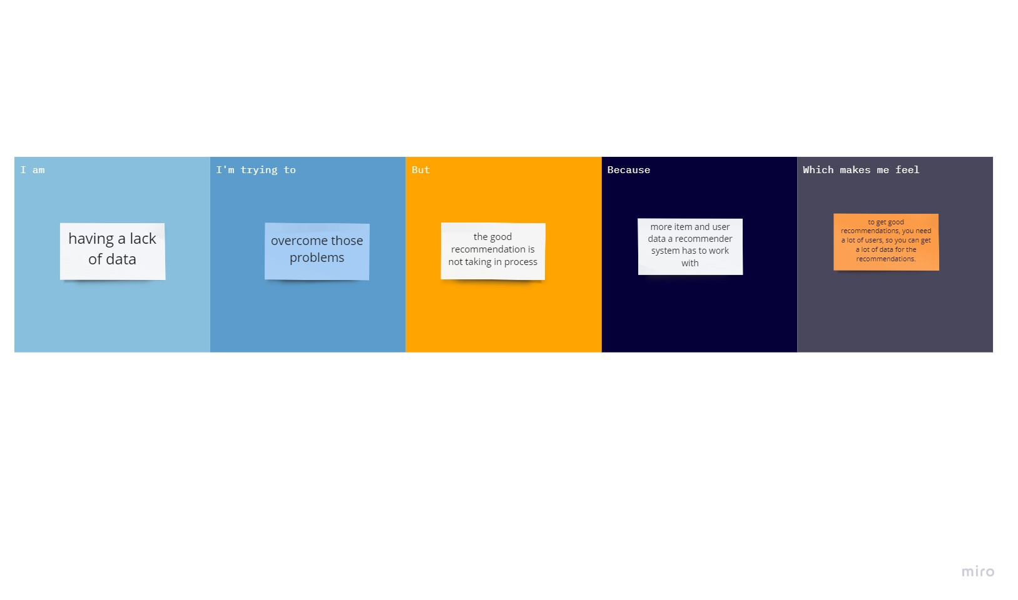

Reference: <https://miro.com/templates/customer-problem-statement/>

**Example:**

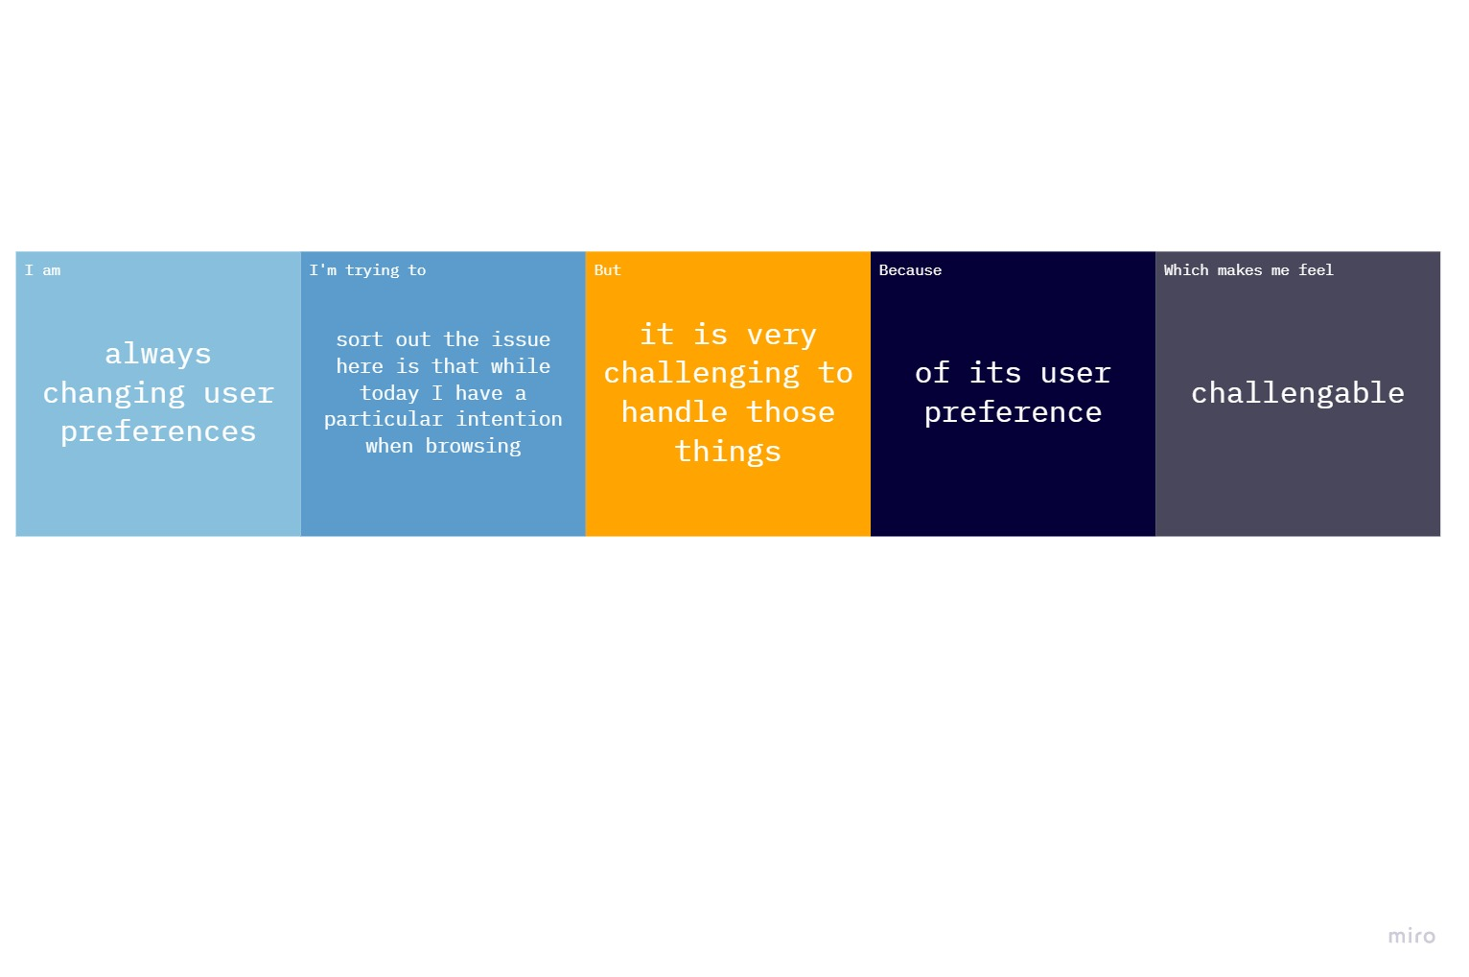

|  |  |  |  |  |  |
| --- | --- | --- | --- | --- | --- |
| **Problem Statement (PS)** | **I am (Customer)** | **I’m trying to** | **But** | **Because** | **Which makes me feel** |
| 1 | Having a lack of data | Overcome those problems | The good recommendation is not taking in progress | More item and user data recommender system has to work with | To get good recommendations |
| 2 | Always changing user preferences | Sort out the issue here is that while today I have a particular intension when browsing | It is very challenging to handle those things | Of its user preference | challengable |